Appendix B

Exchanging Bullets for Bubbles:
Toward a higher and more exalted sphere

Wayne Shute,
in consultation with
Mike and Margie Stroud

Spring 2014
The Bubble

This family paper has been incubating for a year now. I hope you catch the significance of what is said here and try to move along the path that leads to eternal life with a greater vision of Heavenly Father’s love for us and His desire to protect us from all calamities in the last days.

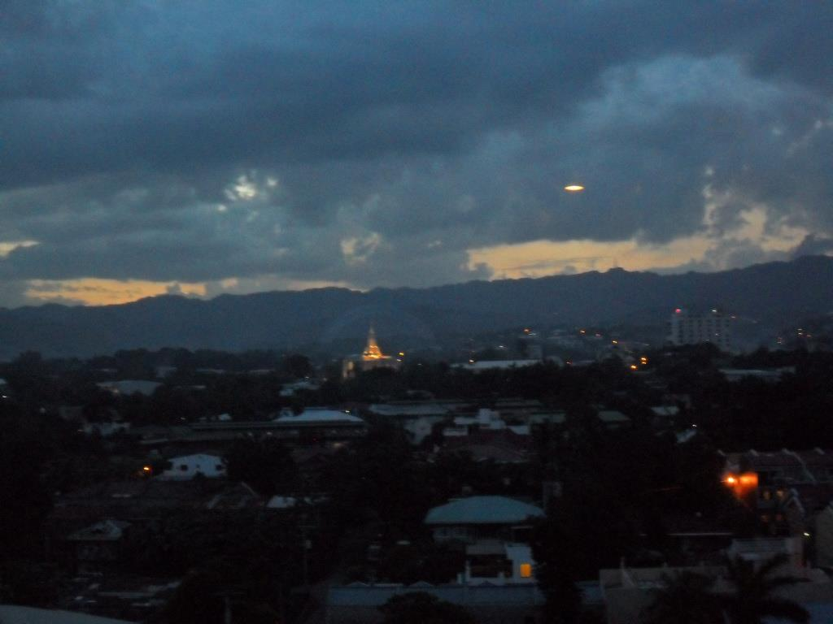
While Mike and Margaret Stroud were serving their mission in the Philippines, we stayed in quite close touch. I was pleased to read their reports and look at the pictures with captions which described their activities. One day, along with a very sobering letter, they sent pictures which a tourist woman took while staying in a hotel in Cebu. In the picture taken from her hotel balcony and taken both in the night and during the day, you can clearly make out a bubble of light which covered over “one of the city’s buildings.” She could clearly make out the bubble of light surrounding a distant building. She was very curious about what she saw and was determined to find out what the building was. She took a taxi over to the building to discover that the building was the recently dedicated Cebu LDS Temple.

She went inside the nearby Mission Office and showed the pictures to Sister Ernstrom who was serving at the time as the Mission Secretary. Sister Ernstrom explained the temple complex to her and asked the tourist woman if she could have copies of the pictures. She was agreeable to that and it wasn’t long before President Schmutz, Cebu Mission President, gave all the senior mission couples copies of the pictures.

Needless to say, the woman was astonished and very impressed with the fact that a Mormon Temple would have such a protective bubble shield over and around it.

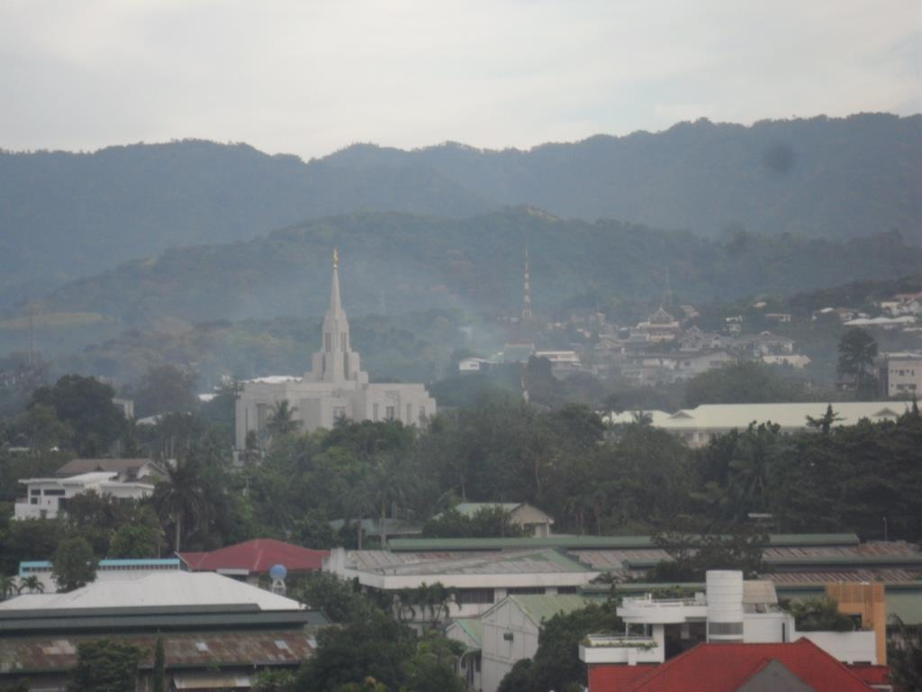
Some time prior to this experience, Mike and Margie had been contemplating the pending geopolitical problems developing in the world, and re-thinking their “what will we do when these awful calamities that are plaguing the world get worse as predicted by prophets?” They had decided some time earlier, that there will always be those with “bigger guns” and more armed personnel than the prepared family in Zion could possibly match. One day Margie said, “Mike, all we need to do is raise our right arm to the square, and use the power of the Priesthood to defend and protect our family and possessions.” Margie’s strong assertion started a focused study aimed at discovering what kind of people have the power to “call down the powers of heaven,” and who can successfully maneuver and survive the tribulation period we have now entered in these the last days. Their belief in calling on the powers of heaven drove them to an in-depth scripture study in an effort to make sense of this unusual phenomenon as the pictures by this tourist woman showed.

Their study also led to a discovery of periods of time in history where God has established Zion societies. Actually, there are only two recorded historical accounts where Zion societies were fully developed: Enoch, and Melchizedek. And there is enough recorded information as to what is entailed in these societies. So, what’s the bottom line? To quote Mike:

It all boils down to this: If we want to survive and thrive in the coming period of upheaval and turmoil, we will need to trust completely in the Lord Jesus Christ, and His power to protect and preserve.

They came to realize that Heavenly Father protects buildings which He wants protected, shielded as it were from the calamities of the world around. Mike and Margie came to realize also that through Priesthood power and with the exercise of our faith, we can expect Heavenly Father to protect us also.

Mike and Margie’s background

Let me now back up a bit and show you the significance of the bubble phenomenon has had in the lives of Mike and Margie Stroud. As with all of us, Mike is greatly defined by the things he has suffered—his first wife was killed in a car accident and died in his arms; his second wife died of cancer; Margie came into the picture about ten years ago as a wonderful companion and help meet. In addition to tragedy, Mike knows a great deal of suffering with regards to his children. We know a little about that but not to the degree Mike does. In most ways, this pain is bitter and causes us great sorrow.

Yet, as we all must do, he carried on with faith in our Savior. He has made every effort to build the Kingdom of God by being a faithful missionary—he served his first mission in Germany; he and Margie served a mission to Mongolia and a second mission to the Philippines. They presently have submitted their papers to serve another mission (Morristown, New Jersey). In all other ways he has been faithful in fulfilling his callings in the Church.

And although Mike has spent most of his career as a top seminary teacher, he really is a cowboy and outdoorsman at heart. During most of his lifetime he has been around farm animals, especially horses. Because of his love for things cowboy, he has collected guns and built up a veritable armory in his house—cowboys tend to collect guns. His gun collection ranged from antique guns to modern firearms. Many of the guns were rare and worth a lot of money. In addition, he had weapons for protection and a huge arsenal of ammunition.

Margie is not at all behind Mike—she has lived a very interesting and successful life. She has a background on a farm and has qualified herself as a mechanic and is well acquainted with animals and all kinds of work that are associated with this lifestyle. Over many years, she has taught elementary education and is a superb teacher. She has filled all kinds of assignments in the Church and is a student of the scriptures. She is perfectly yoked with Mike in their love of the Gospel and their faith in Jesus Christ.

A Powerful Example to all of us in becoming Self-reliant

When they came together, they were determined to follow the prophets and build a self-reliant environment in their home in Eagar, Arizona. They threw their full hearts into building a self-sustaining home and built a place that is completely independent of outside support. They have followed the admonitions of prophets and apostles to be prepared. You know what their counsel has been. Accordingly, they have, in my opinion, the best food storage, emergency storage system probably in the Church. You have to really see it to understand what I mean. They have prepared themselves beyond measure. They define for us what it means to be fully prepared for the turmoil, even the horror of the last days. In our view, we will face indescribable hardship; to do so we must be fully prepared. As the scripture notes, “if you are prepared, you need not fear.”

Behold, this I have given unto you as a parable, and it is even as I am. I say unto you, be one; and if ye are not one ye are not mine.

And again, I say unto you that the enemy in the secret chambers seeketh your lives.’’ Ye hear of wars in fara countries, and you say that there will soon be great wars in far countries, but ye now not the hearts of men in your own land.

I tell you these things because of your prayers; wherefore, treasure up wisdom in your bosoms, lest the wickedness of men reveal these things unto you by their wickedness, in a manner which shall speak in your ears with a voice louder than that which shall shake the earth; but if ye are prepared ye shall not fear (D&C 38:27-30).

Naturally, they have been concerned about protecting what they have worked so hard to build. They, like all of us, have a great desire to protect our property; our homes and the lives of all of us. The modern weapons they have stored have been to protect their family and their possessions.

About three years ago, as some of you will remember, Mike spoke to our family about food storage and emergency preparation. He gave a lot of interesting information about the coming trials and test in these the last days. He talked about how we all will face many trials whether they be economic, political, or spiritual. In many cases our lives will be threatened and there will be vandals, thugs, even murderers who may threaten our lives and our property. He didn’t hold back in painting a clear picture of what to expect in the coming years.

He spent some time during that talk about the need for weapons to protect our lives and the lives of our loved-ones.

The Relevance of the Bubble for us

While visiting with us recently, they shared the scriptures that have turned their lives around and given them a new perspective on what we can expect if we seek protection from our Father in Heaven and His Son, Jesus Christ. They have a completely different focus now and have reversed themselves 180 degrees. I’ll say more about this later, but for now let’s walk through some of the scriptures which have changed their lives so dramatically.

From the Book of Revelation 13:10, we read the following:

He that leadeth into captivity shall go into captivity; he that killeth with the sword must be killed with the sword. Here is the patience and the faith of the Saints.
In explaining this scripture, Mike offers the following:
The patience of the Saints in this verse refers to a previous verse (7) which talks about Satan making war upon the Saints and OVERCOMING THEM. I believe that at some time in the future, we as Americans, and as Latter-day Saints will be led into captivity by foreign invading powers, and that we like Alma will need to learn to submit to these powers. We will be delivered miraculously, by the Power of God, but will need to put our trust in him, and WAIT (the patience of the Saints) for His deliverance. The two stories of Ammon/Limhi, and Alma and his people, teach us a powerful principle of trying to escape captivity by the force of our own arm, or by trusting on the Arm of the Lord. (Read Mosiah 21 -22, and Mosiah 23-24)
Mike and Margie were pretty sobered when they read these and other scriptures. Those who have weapons may be tempted to kill the thugs or marauders who may be beating and pounding on the door. But if you answer in kind, with guns yourself, someone will get hurt or killed. And it may be you or your loved ones! No, we have greater weapons at our disposal than guns!
In addition to that scripture above, they were mightily impressed with another from the Doctrine and Covenants D&C 105:14. Here’s what that verse says:
For behold, I do not require at their hands to fight the battles of Zion; for, as I said in a former commandment, even so will I fulfill—I will fight your battles.
Mike enlarged on this scripture as follows:
See also DC 45:66-75, Moses 7:13-14, JST Genesis 14:25-40. Pay close attention to these scriptures! Notice that the people of God in these references do not take weapons. God fights their battles, and uses men and women endowed with priesthood power to command elements, and call down the powers of heaven in their behalf.
When these scriptures were reviewed with us recently, we talked about how in the Book of Mormon, much time and energy was spent by the Nephites in making preparations for war. They had weapons and fielded the best equipped armies they could muster. I said to Mike, “Those folks had weapons of war to protect their homes, families, etc. Shouldn’t we also?” Here Mike taught us a great lesson. He said, “You have to remember, we are talking about the concept of Zion. You won’t find the concept of Zion had much meaning to the Nephite generations. When Zion is mentioned in the Book of Mormon it is through Isaiah and his vision of our times or it is a vision that Nephi had concerning our times in which we covenant to build up Zion. We must remember that in Nephite times, they fought wars to protect their families and land, etc. but they were not fighting to build up a Zion society. You never read about them building up Zion. They were not a Zion people—in effect, they were fighting to save their country. In order to protect their country, they needed weapons of war. When the time comes that we must fight to protect our country and our Constitution, we will no doubt need weapons of war.

A Zion People
But when we’re talking about building Zion, that is a different matter. There will be a small remnant (Joel 2:32) from within this people (Latter-day Saints) who will become Zion men and women. The rights and privileges of these Saints (sanctified Ones) are described in the following verses of scripture: DC 67:10-14, DC 76:50 -70, DC 84: 18-25, DC 88:63-68, DC 93:1-2, DC 107:18-19. These people are best described In JST Genesis 14:25-40 Enoch and Melchizedek were patterns of the type of people we will need to be in order to survive what’s coming. Notice also what Abraham is seeking for in Abraham 1:2-4. Read closely also DC 50:26-30. This is a very powerful scripture about a bestowal of power from Christ himself. Again, this pertains to this life.
But,, as we review these scriptures, they are referring to us as a Zion people. We are talking about building and protecting Zion. So, when building Zion—and we do that by being faithful to our Heavenly Father—it is clear that the Lord God Almighty will protect us. He will “fight [y]our battles” and protect His people. So faithful people of the Lord don’t need guns to protect what they have—God Himself will extend His mighty arm and protect His people.
All of this can be said in a different way. Said Mike,
when we are fighting for the cause of Zion, we don’t need weapons of war. But we can’t get this confused with the Second Amendment of the Constitution which purpose is to protect the Constitution of the United States. That has nothing to do with establishing Zion.” It’s OK to have arms to protect the country, but we don’t need weapons of war to establish and protect Zion.
When we make the effort to have a food storage program for the blessing of our families, that food storage program becomes part of our faith in building the Kingdom of God. To repeat, it is part of building the Kingdom of God on the earth and strengthening Zion. The Food Storage program of the Church is first and foremost about obedience. Everything we do within the program of temporal preparedness can vanish in the coming day. Our obedience to this command, qualifies us to become Zion individuals, and to perform miracles when the need arises. Those who have not been obedient in following the prophets will not be able to become the men and women who can command “the very trees, the mountains, or the waves of the sea”, and have them obey. (Jacob 4:6)
Here are two other scriptures of great significance for us.
And their arm shall be my arm, and I will be their shield and their buckler; and I will gird up their loins and they shall fight manfully for me and their enemies shall be under their feet; and I will let fall the sword in their behalf, and by the fire of mine indignation will I preserve them (D&C 35:14).
And I the Lord, would fight their battles, and their children’s battles, and their children’s children’s, until they had avenged themselves on all their enemies, to the third and fourth generation (D&C 98:37).
Faith to move mountains
What we’re talking about here is a completely different look at the power of the Priesthood and the power of faith in the Lord Jesus Christ. When we do have the faith to call down the powers of heaven to protect us, then God will lay bare His mighty arm and protect us. He will put a bubble over our houses and lands in so much that no one will dare to try to hurt us or if they do want to hurt us they will become the victims of God’s wrath. It is not beyond reason that people who want to hurt us or steal our food storage won’t be able to even see us and our possessions. There is no reason to doubt but what Heavenly Father could make our places invisible to those who would hurt us or want to take by force the things we have.
Some of us may say, “I don’t have that kind of faith so I’m going to rely on my guns to protect me.” Well, there are consequences to that kind of thinking. As I’ve said above, you or someone you love may be the ones who will suffer (DC 45:68).
What I’ve decided to do is try to show my love toward a kind and merciful God. I will show this love by expressing daily my gratitude for His tender mercies; by acknowledging His power and inviting His protection. And when I do this, I can expect bubbles of protection to be above and around the ones I love and cherish.
Mike and Margie add the following to this discussion:
If God our Father is the same yesterday, today, and forever…and if he is unchanging, then it stands to reason that every miracle, sign, power, endowment, and gift received by others mentioned in the scripture, is available to us today. If not so, God is a respecter of persons, and ceases to be God. This is the beauty of the Gospel of Jesus Christ: Not only is it TRUE, but it WORKS! Everything we read about God’s dealings with his children in history is available to us today. We can face the future with faith and confidence that through the Lord’s power, we can become invisible to our enemies, we can traverse time and space, we can stand in the presence of the Father and the Son, and do ALL THINGS according to HIS WORD! And all of this, WHILE IN THIS LIFE!
Once we came to this realization, and had it powerfully confirmed through the Holy Spirit, it all made sense, and we felt the “Call to Zion.” To demonstrate to the Lord that we were willing to not only “see and hear”, but to “do”, (DC 84: 54-49) we made plans to offer a sacrifice to Him as a token of our faith and trust. The first thing we did when we returned home from the Philippines, was to sell all of our battle weapons, and thousands of rounds of military ammunition. This was ironic, because at the time we did this, millions were buying these weapons and ammunition, and thought we were crazy for selling. From that time to this, this principle continues to grow stronger and stronger as we Ask, Seek, and Knock to be bestowed with the privileges and promises found in the scriptures, and in the Temple.
The Spirit of the Lord is hovering over, and persuading a remnant of this people to come up to this level, and claim these blessings. This isn’t something we become on our own, it is the person He makes us through the cleansing, purifying, and sanctifying power of the Atonement of Jesus Christ. (Alma 13:12) It is our desire to become a part of this remnant (Joel 2:32).
My Personal goal and I hope the goal of all Shute Family members
All of this has a great meaning for me and I think for our entire family. For me, I have set a personal goal to become worthy to become one of the remnant of people who are full of faith and become, therefore, worthy to be a part of Zion. This will come through my exercise of faith and strict obedience to Heavenly Father’s commandments—all of them. I must, as we are informed in the Lectures on Faith, “pursue a course of life that is pleasing to God” and no sacrifice is too great in order to have this sure knowledge.
As for our entire family, the same goal should apply. Most of you, according to my observation, are heading in the right direction, but there is still a long way to go for some of us, less of a journey for others. I urge us all to take a spiritual inventory and begin now to have a greater vision of what is required of us in order to become a Zion people.
Part of that spiritual journey will be to be faithful temple attenders for it is in the temple that, if we are observant, we will see the greater vision of what is possible for us.

