Baking Bread using the Wonder Box

http://eatingfoodstorage.blogspot.com/2010/02/word-about-wonder-ovens.html

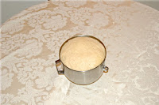
Here are some pictures of me using the wonder oven to bake bread.
Make your favorite bread recipe as usual and let rise until double.

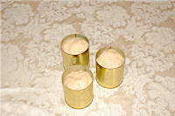
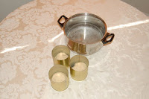
Then punch down and divide into 3 equal parts (I use a small scale to make sure they are equal weight). Place into greased large V-8 cans and put in your pot with warm water. Water should come about half way up the can and your pot should be as small as possible while still allowing the lid to close snugly.
Let rise in the pot with the lid on until dough is about 1 inch from the top of the cans. Remove cans from pot and cover with tinfoil.

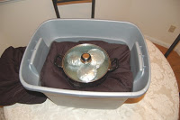
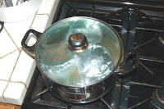
Secure tinfoil to can with tape or rubber band and place back in pot of water on the stove. Bring to a boil and boil for 10 minutes.

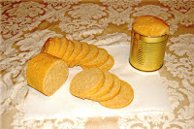
Immediately remove from heat but DO NOT remove the lid. Quickly transfer entire pot to wonder oven. Place on bottom pillow and cover with the top pillow. Do not disturb for at least 2 hours. You can leave it as long as you want. Food will not burn or over bake. Feel free to run errands while your bread is baking!
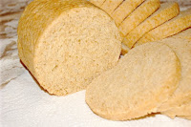
After at least 2 hours remove bread from wonder oven. Slide out of can. You will notice right away that this bread does not have a crust. Kids LOVE it!
Cut into slices and you have nice round bread that is the perfect size for sandwiches!

