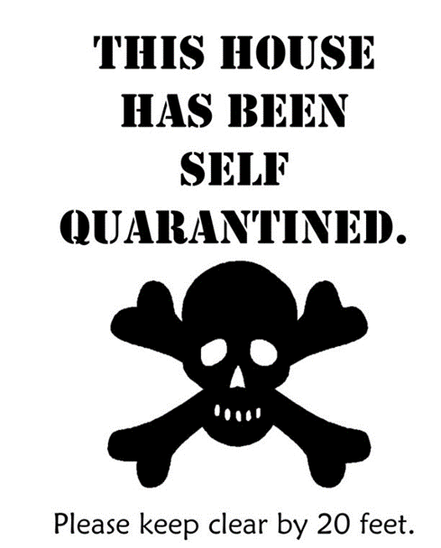

Please call to communicate!

________________________